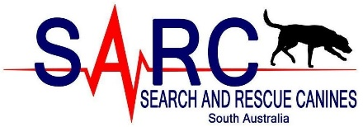
“Without search there is no rescue”
Assistant/Visitor Information Sheet
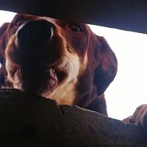
Many thanks for volunteering to help SARC-SA and our Urban Search and Rescue (USAR) canine and handler teams prepare for real world situations. We train for work in the field, searching for missing, lost or injured people, specifically in situations such as the Thredbo landslide, Christchurch earthquake, and post bushfire and flood. We also train our teams for the search for missing persons in urban, suburban and wilderness environments. Assistants are invaluable to the success of the capability and next to the dog and handler are one of the most important part of the training process.

To ensure your safety and welfare on your first visit please read the following points:

Attire
- Long sleeved shirt\jumper (T-shirt underneath especially in summer)
- Full length trousers
- Closed-in sturdy shoes (Steele-toe cap if you have)
- Hat and Sunscreen
- Other PPE will provided
- Water is provided
- Lunch and snacks

The places where you will be hiding can be dusty/wet/muddy/capable of tearing clothing so ensure your clothes are suitable to handle a little dirt. Please ensure you dress to the weather conditions.

Time (session end time a little variable depending on speed of dog’s noses!)
Saturday – 09:00 am start to approximate 1:00 pm finish. Induction will start at 09:00 am sharp and will take approximately 30 minutes.

Location
Gate 4, 480 Grand Junction Road,
Angle Park (SAMFS training facility)
https://www.google.com.au/maps/search/mfs+angle+park+map/@-34.8523661,138.5402543,14z link to map (be a little wary of GPS directions for this address, as it sometimes directs to a street nearby rather than direct to location).

Recruit / Assistant Contacts
Emma 0408 804 811/Carla 0433 344 352 sound may be turned down if we are training but will be monitoring texts.
Feel free to contact us with any questions.

Looking forward to seeing you there!

